**Department of Computer Science & Engineering**

PSITCOE

**Kanpur, Uttar Pradesh**

**B.Tech- I.T(4th Year)**

**(Seventh Semester)**

**Industrial Training Lab**

**(NCS-753)**

**LAB FILE**

**Submitted To: Submitted By:**

**Ms. Priya Singh Anshul Gupta**

**(Asst. Professor) I.T-IV-YEAR**

**CSE Department 1534813011**

**DECLARATION**

I hereby declare that the project entitled ‘**Smart Voting System Support through Face Recognition’** submitted for the B.Tech degree is our original work and the project has not formed the basis for the award of any other degree associate-ship, fellowship or any other similar titles.

**Signature:**

**Name : Anshul Gupta**

**Roll No : 1534813011**

**Date** **:**

**(Ms. Priya Singh)**

**(Assistant Professor)**

TABLE OF CONTENT

ABSTRACT x

CHAPTER 1 : INTRODUCTION 1

* 1. Problem Statement………………………………………………………...1
  2. Purpose……………………………………………………………………1

CHAPTER 2 : LITERATURE SURVEY…………………………………………………..2

2.1 Existing System...........................................................................................2

2.2 Proposed System..........................................................................................2

2.2.1 Eigen Face Algorithm..........................................................................3

2.2.2 Principal Component Analysis............................................................3

CHAPTER 3. WORKING FLOW OF THE SYSTEM...........................................................4

CHAPTER 4. STEPS IN VOTING.........................................................................................5

CHAPTER 5. FUTURE SCOPE.............................................................................................6

CHAPTER 6 CONCLUSION……………………………………………………………….7

**ABSTRACT**

* In this a new authentication technique in online voting system using facial recognition of the voter is used. In India, currently there are two types of voting system in practice. They are secret Ballet paper and Electronic Voting Machines (EVM), but both of the process have some limitation or demerits.
* In India online voting has not been yet implemented. The current voting system is not safe and secure too.
* The voters need to go to distributed places like polling booths and stand in a long queue to cast their vote, because of these reasons most of the people misses their chance of voting.
* The voter who is not eligible can also cast its vote by fake means which may leads to many problems.
* That’s why in this project we have to propose a system or way for voting which is very effective or useful in voting. In our approach we have three level of security in voting process.

**1. INTRODUCTION**

* 1. Problem Statement

Now a day in India two types of method are used for voting. The first method is secret ballot paper, in which lots of paper are used and second method is EVM (electronic voting machine) which is used since 2003. We have to propose a method or way for online voting that is more secure than the existing system.

1.2 Purpose

In this proposed project face detection and recognition concept is used to identify the exact person. There are three levels of verification were used for the voters in our proposed system.

The first one is Unique id number verification, second level of verification is election commission id or voter card number, if your election commission id number is correct then you have to go for third level of security which is the main security level where the system recognize the face of the real voter from the current database of face images given by the election commission. If the captured image is matched with the respective image of the voter in the database, then a voter can cast their vote in the election.

**2. Literature survey**

2.1 Existing System

In the India, the manual voting system is still preferred which is accomplished in a single day, so the security of our valuable vote is not as much as considered. The huge amount of man power is required to maintain security. The poll allocation is done in advance by the election commission. Normally the polls are the schools or community halls.

For voting purpose EVM i.e. Electronic voting machine is used. This voting method is preferably used for voting.

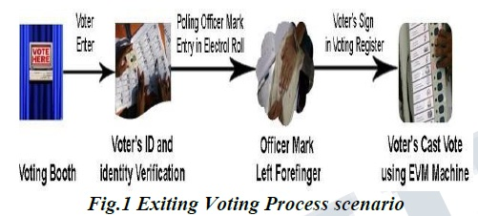

2.2 Proposed System

In this project we are working with three different security levels.

Level1: -Unique id number (UID) :-

At the time of voter registration system will request for the unique id from the voter. The entered unique id is verified from the database provide by the election commission.

Level2: Election commission id card number:-

In the second level of verification, the voter has to enter the election commission id or voter’s id number. The entered id number is verified from the database provide by the election commission.

Level3: - Face recognition with respective election commission id number:-

In this level, Eigen face algorithm is used to verify the facial image of the voters from the database provided by the election commission.

2.2.1 Eigen Face Algorithm:-

* Eigenfaces are the Eigen vectors of Covarience matrix of the dataset.
* Eigen faces are also referred to as Ghostly images.
* Prime reason->To represent the input data efficiently-each individual face can be represented in terms of linear combination of eigenfaces.
* Can be reduced dimentionally using Principal Component Analysis(PCA)

2.2.2 PRINCIPAL COMPONENT ANALYSIS:-

* Used to remove information which is not useful, therefore it reduces the dimension of the data and accurately decompose the face structure into orthogonal principal component which we know as “EigenFaces”.

**3. WORKING FLOW OF THE SYSTEM**

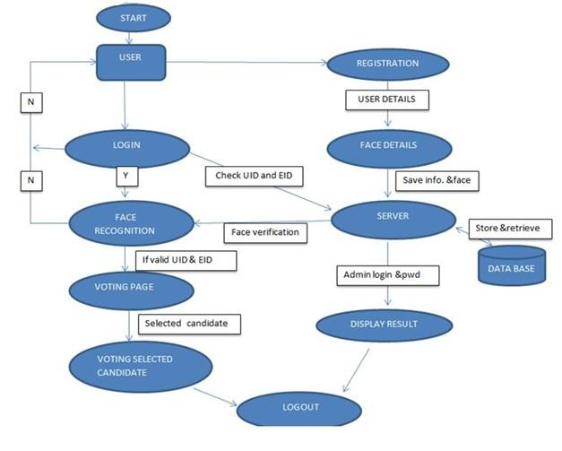

**4. STEPS IN VOTING**

* Every New User in the India is first register for Voting. So, our first step is registration
* At that time of Registration System Capture, the Face of the user by using Web Camera and Store the Face sample in the Server Database for Security Purpose.
* At the time of election, we will use three level of security first one is unique id verification second one is voter id verification third one is face recognition.
* System will be checking whatever unique id and voter id entered by the voter is correct or not.
* If unique id or voter id is correct than system will take image of voter and compare with the respective image of database or server.
* If the image in database is matching with the captured image of the voter, then he/she is allowed to cast vote.
* On the voting page all the party whatever party contest in the election symbols /buttons will be there. Voter can cast his /her vote in the election.
* As soon as voter will give vote the id of voter logout automatically so we can say that a voter can give only one vote.
* On counting form only election commission authorized user can login with the secure id and password if both id and password is correct then voting process will be continuing.

**5. FUTURE SCOPE**

In this system we have proposed a method of highly Secure Online Voting System. The security of our system is greatly improved by the new idea of matching real time captured image on the basis image shares. The system is usable as it is very reliable system in real life. By using this system, time required to vote candidate is very less, so it is definitely helpful to a voter who want to give a vote to the desirable candidate. For the future enhancement the system can Send SMS to the voter for confirmation of voting i.e. vote is given successfully.

**6. CONCLUSION**

As we see that existing voting system has many defects such as lengthy process, time taking, not secure, bogus voting, no security level but now we can say that our approach is more useful and secure from the existing system. Since, we are using three level of security in this proposed system the false voters can be easily identified. The facial authentication technique is very much useful in identifying the fraud voters, so we can avoid the bogus votes during election commission.

The voters can cast their voting from anywhere by login to our proposed smart voting system through internet. As every operation is performed through internet connectivity so, it is onetime investment for government. Voters’ location is not important but their voting is important. As data is stored in centralized repository so, data is accessible at any time as well as backup of the data is possible. Smart voting system provides updated result at each and every minute. Also requires less man power and resources. The database needs to be updated every year or before election so that new eligible citizens may be enrolled and those who are dead are removed from the voter list.